# Name – yashuman

# UID – 23BIS70089

# EXPERIMENT – 11

# AIM - REST API for Playing Card Collection Using Express.js

## Objective

Build a RESTful API using Express.js to manage a collection of playing cards. This task helps you understand routing, handling HTTP methods, and basic data manipulation in a Node.js backend environment.

## Task Description

Create an Express.js server that provides API endpoints to manage a playing card collection. The API should allow you to perform operations such as listing all cards, adding a new card retrieving a specific card by ID, and deleting a card by ID. Store card data in an in-memory array for simplicity.

CODE:

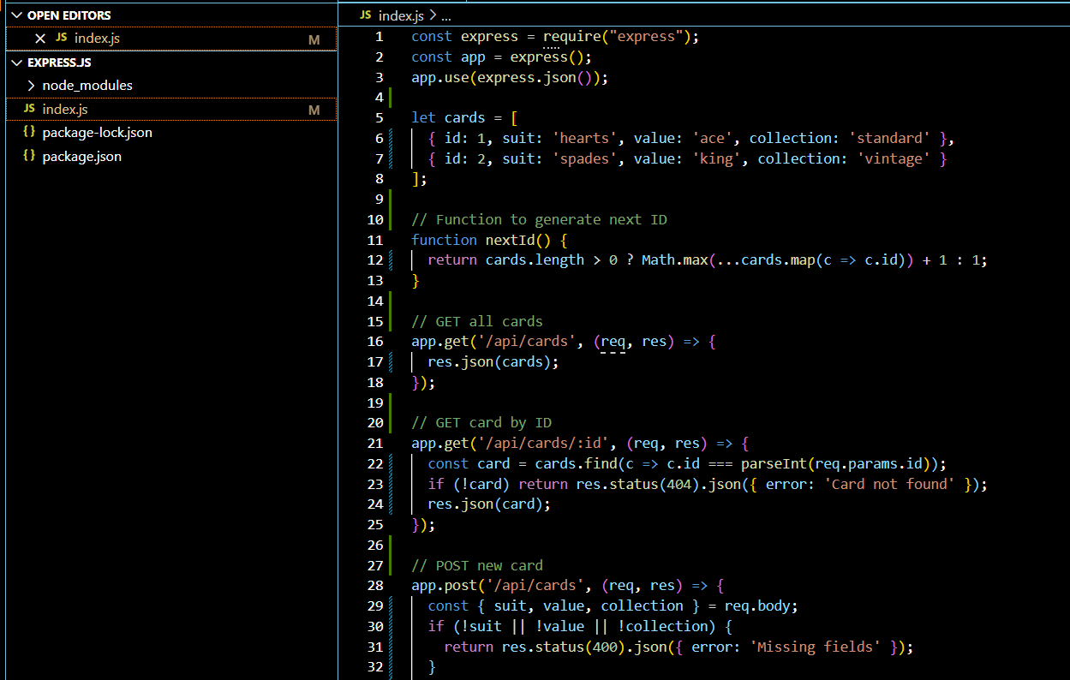

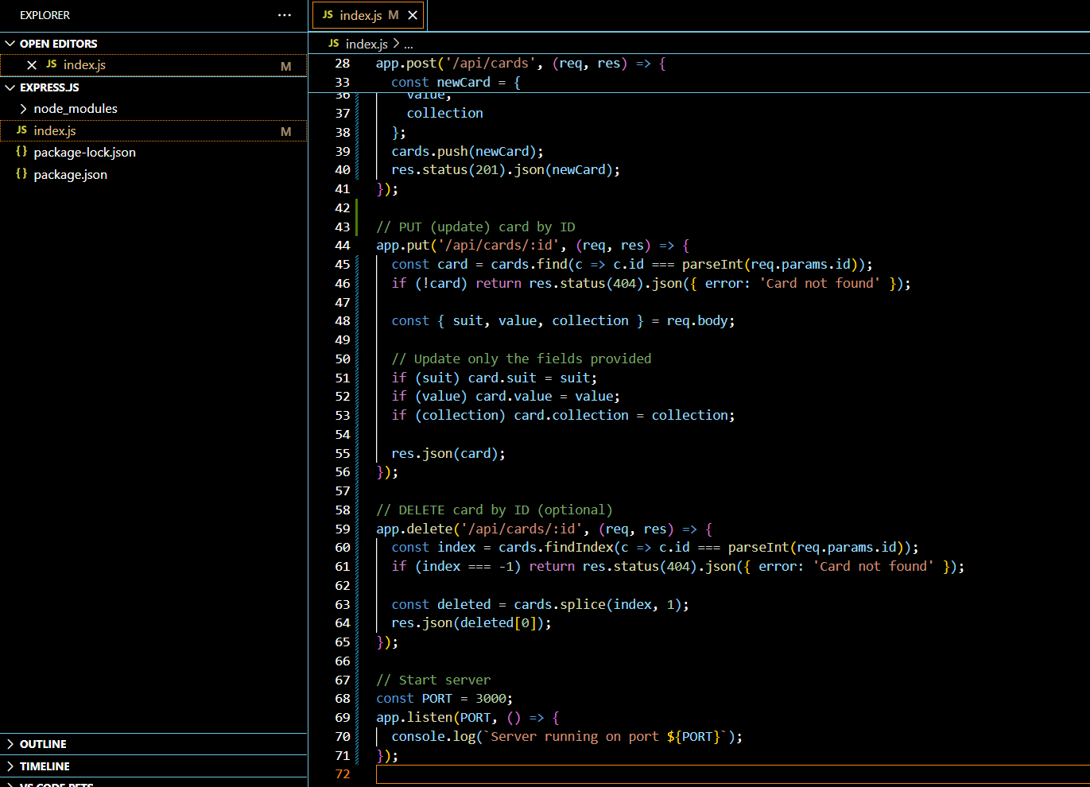

OUTPUT:

